

Experiment No. 5

Title: Computing probability of sentence using Bi-grams
Batch: NLP–1 Experiment No.: 05

Roll No.: 16010422234 Name: Chandana Galgali
______________________________________________________________________________

Aim of the Experiment: To compute probability of sentence using Bi-grams
______________________________________________________________________________

Program/Steps:
1. Implement a Bi-gram model to compute the probability of sentence
______________________________________________________________________________

Output/Result:

import collections

corpus = [
"A boy is playing in the park",
"A girl is playing with a dog",
"The dog is running in the park",
"The boy is running after the dog"
]

sentence_to_calculate = "The boy is playing with a dog"

print("--- Preprocessing Data ---")
tokenized_corpus = [['<s>'] + s.lower().split() + ['</s>'] for s in corpus]
tokenized_sentence = ['<s>'] + sentence_to_calculate.lower().split() + ['</s>']
print("Tokenized Target Sentence:", tokenized_sentence)
print("-" * 25)

print("--- Counting Frequencies from Corpus ---")
all_words = [word for sent in tokenized_corpus for word in sent]
unigram_counts = collections.Counter(all_words)
bigram_counts = collections.Counter()
for sent in tokenized_corpus:
bigram_counts.update(zip(sent, sent[1:]))

print(f"Unigram Count for 'boy': {unigram_counts['boy']}")
print(f"Bi-gram Count for ('is', 'playing'): {bigram_counts[('is', 'playing')]}")
print("-" * 25)

print(f"--- Calculating Probability for: '{sentence_to_calculate}' ---")
sentence_probability = 1.0
sentence_bigrams = list(zip(tokenized_sentence, tokenized_sentence[1:]))

for bigram in sentence_bigrams:
prev_word, current_word = bigram
bi_count = bigram_counts[bigram]
uni_count = unigram_counts[prev_word]

if uni_count == 0 or bi_count == 0:
conditional_prob = 0
else:
conditional_prob = bi_count / uni_count

print(f"P({current_word:^9} | {prev_word:^9}) = {bi_count} / {uni_count} = {conditional_prob:.4f}")
sentence_probability *= conditional_prob

print("-" * 25)
print("--- Final Result ---")
print(f"The probability of the sentence is: {sentence_probability}")
print(f"P('{sentence_to_calculate}') = {sentence_probability:.6f}")

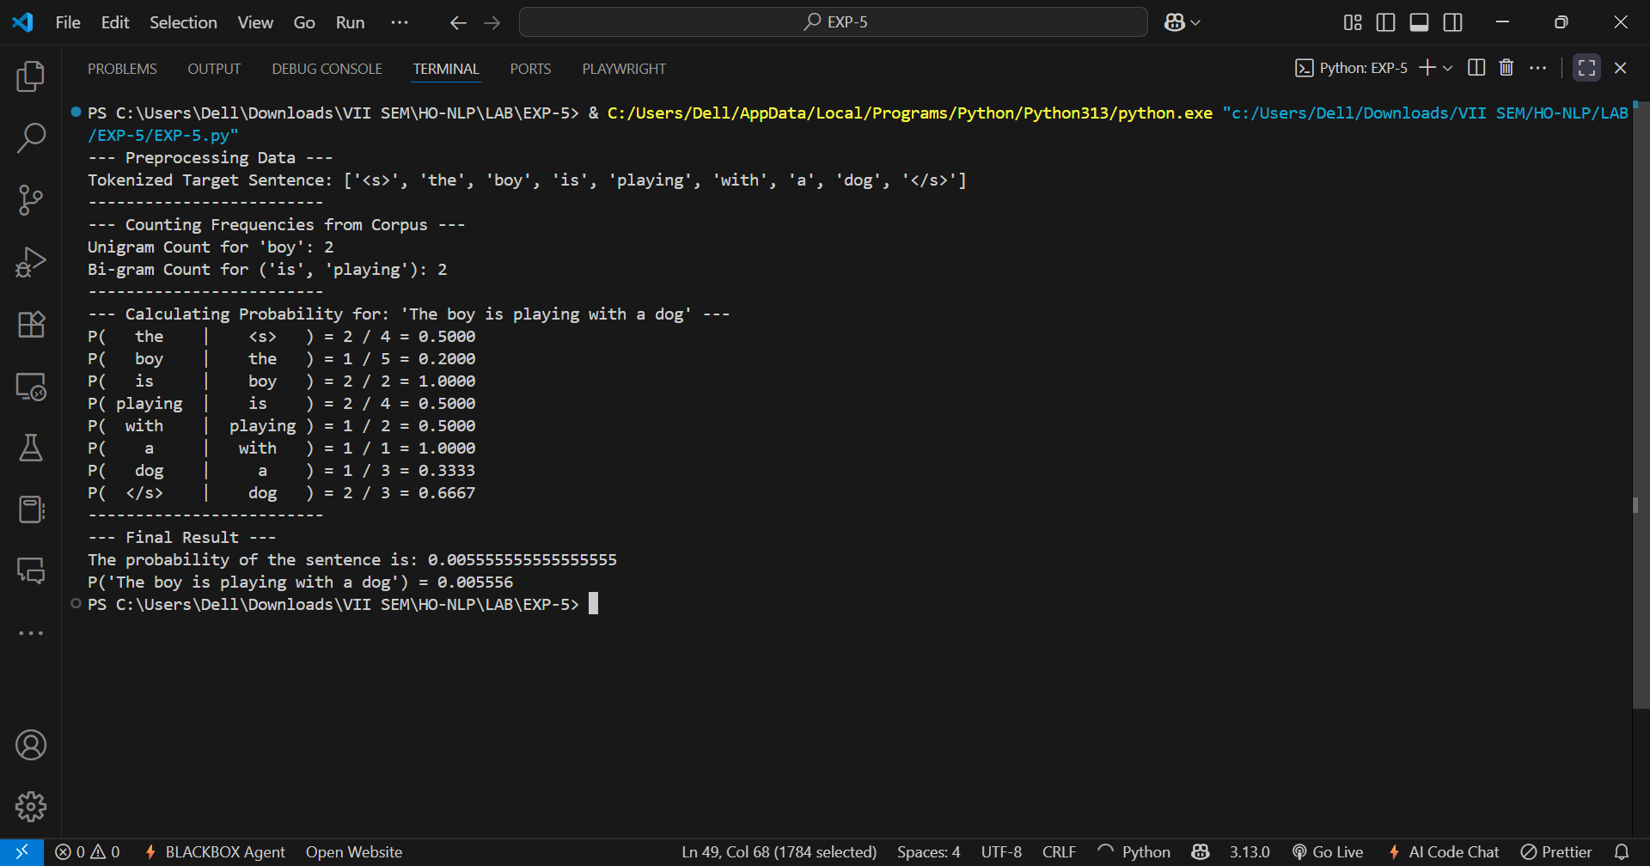

______________________________________________________________________________
Post Lab Question-Answers:
- Explain how the probability of a sentence is computed using a bi-gram model. Illustrate your answer with an example sentence
Ans: A bi-gram model calculates the probability of a sentence by multiplying the probabilities of each word based only on its preceding word. This is known as the Markov assumption.
The probability of a word (wi​) given its previous word (wi−1​) is calculated from a text corpus using the formula:
P(wi​∣wi−1​)=​Count of the pair (wi−1​,wi​)​/Total count of the word wi−1
The final sentence probability is the product of these individual conditional probabilities.
Example:
Let's find the probability of the sentence "the cat sat" using this simple corpus:
- Corpus: "the cat sat on the mat", "the dog sat on the log"
1. Calculate individual probabilities:
- The probability of "cat" following "the" is: P(cat∣the)=Count(the, cat)/Count(the)​=1/4​=0.25 (The pair "the cat" appears 1 time; the word "the" appears 4 times).
- The probability of "sat" following "cat" is: P(sat∣cat)=Count(cat, sat)/Count(cat)​=1/1​=1.0 (The pair "cat sat" appears 1 time; the word "cat" appears 1 time).
2. Multiply the probabilities:
- P("the cat sat")=P(cat∣the)×P(sat∣cat)=0.25×1.0=0.25
______________________________________________________________________________

Outcomes: CO3 – Establish concept of Structure and Semantics
______________________________________________________________________________

Conclusion (based on the Results and outcomes achieved):
This experiment successfully demonstrated the computation of a sentence's probability using a bi-gram model. By tokenizing a corpus, counting the frequencies of unigrams (single words) and bi-grams (adjacent word pairs), we were able to implement the underlying probabilistic logic. The final probability of a target sentence was calculated by multiplying the conditional probabilities of each word given its preceding word. This practical exercise highlights how n-gram models, despite their simplicity, form a foundational concept in Natural Language Processing for quantifying the likelihood of text sequences.
______________________________________________________________________________

References:
Books/ Journals/ Websites:
- Allen James, Natural Language Understanding, Benjamin Cumming, Second Edition, 1995
- Jurafsky, Dan and Martin, James, Speech and Language Processing, Prentice Hall, 2008
- Palash Goyal, Karan Jain, Sumit Pandey,Deep Learning for Natural Language Processing: Creating Neural Networks with Python, Apress, 2018
______________________________________________________________________________

